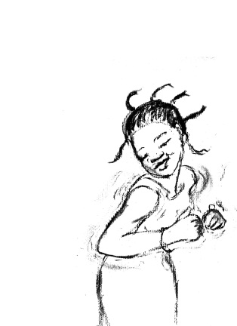“Bring on the Sunshine”
Multicultural programming for children
Registration Form
CAMP DATES: August 14th – 18th, 2017
CAMP LOCATION: St Johns Lutheran Church, 22 Willow St, Waterloo
Child’s name:………………………………………………………………………………Sex:………………...
Birthdate: ……………………………………………………Age at time of Camp:…………………………………………
Address…………………………………………………………………………………………………………………………….……
City: ………………………………………………………………………………Postal code…………………………………
Parent/Guardian……………………………………………………………………………………………………………
Telephone: Home ………………………………… Business: ………………………..………………………………
Cell: ………………………………………………………Email: …………………… …………………..………………………
I am registering for the full week program and have enclosed $140 □ Yes □ No
OR
I am registering for (no)…………days ($35/day) & have enclosed the amount of $........................
□ Monday □ Tuesday □ Wednesday □ Thursday □ Friday
Please complete one form per registrant!
Times are from 9 -4 pm. Extended care may be available upon request. Please communicate with us directly.
Make checks payable to Bring on the Sunshine and Mail to 14 Limera Rd, Elmira, ON N2B 0B6. Receipts will be available for pick up at camp.
A charge of $20 will be collected on NSF cheques. You will receive your receipt upon payment. Your database entry serves as a preregistration only; your check reserves your space In the camp. Checks must be sent within two weeks of registration.
Refund Policy: a full refund, minus a $25 processing fee will be given if arrangements for cancellations are made at least 2 weeks prior to that start of the intended registered session. Cancellation requests without 2 weeks notice will be charged a $75 processing fee. Further more, cancellations within 1 week of less notice will be reimbursed fifty percent of the camp fees.
MEDICAL INFORMATION
Please indicate any medical problems, behavioural problems, allergies, medication, or special needs of which camp staff should be aware. Please be specific. If you have filled out this portion you will be sent an additional medical form.
………………………………………………………………………………………………………………………………………………………………………………………………………………………………………………………………………………………………………………………………………………………………………………………………………………………………………………………………
Doctors name: …………………………………………Health Card no: …………………………………………………………
PICTURES
We take pictures for our bulletin board and promotional material.
May your child have their picture taken? □ Yes □ No
PHOTOS
Would you child like to have a emailed copy of their group photo? □ Yes □ No
SIGN IN & SIGN OUT
In order to ensure the safety of all our campers, your child(ren) must be signed out with a staff member. Only people listed below will be allowed to sign out a camper.
Campers name:………………………………………………………………….… Session:…………………………………..
I authorise the following people to pick up my child(ren) (Please remember to include yourself)
Name:………………………………………………………….Daytime phone ……………………………
Name:………………………………………………………….Daytime phone ……………………………
Name:………………………………………………………….Daytime phone ……………………………

Parents or Guardian’s signature…………………………………………………………..Date:…………….

INDEMNIFICATION AND RELEASE
I,____________________________________________, hereby release and forever discharge Bring on the Sunshine and its receptive officers’ and agents from and against all claims, actions, costs, damages and expenses with respect to damage and/or bodily injury to my child as a result of his or her participation in the above camp.
I understand that Bring on the Sunshine has a violence free policy to ensure the safety of all participants. Any behavioural misconduct will result in immediate removal from this program, with no money refunded.
I declare having read and understood the indemnification and release form in its entirety and hereby agree to be bound by that terms and conditions. Understanding the terms and conditions of this indemnification and release, I give my consent for the registrant to participate.
Date: ……………………………………………
Signature:……………………………………………………………witness:……………………………………
Parent or guardian

Bring on the Sunshine believes that every child should have the opportunity to attend camp. Please consider a personal or company donation of $20.00 or more towards our bursary fund and put a smile on a child’s face who otherwise may not have been able to attend camp. We rely solely on donations to provide subsidies to families in need. If you would like a tax receipt for this amount please check the appropriate box.
I would like to make a donation towards subsidizing another child □ Yes □ No
I would like a tax receipt for my donation: □ Yes □ No
Donation Amount enclosed $.....................................

